# **Case Analysis (Git and GitHub Workflow)**

## **Quiambao Documentation**

### **Remote Repository (GitHub) Creating a Milestone**

**THIS PICTURE IS THE MILESTONE OF OUR REPOSITORY MADE BY THE LEADER IN GITHUB REPOSITORY.**

**IN THIS PICTUREIS IS THE ISSUES OF OUR REPOSITORY MADE OF OUR LEADER THAT EACH MEMBER REQUIRED TO COMMENT THE ISSUES**

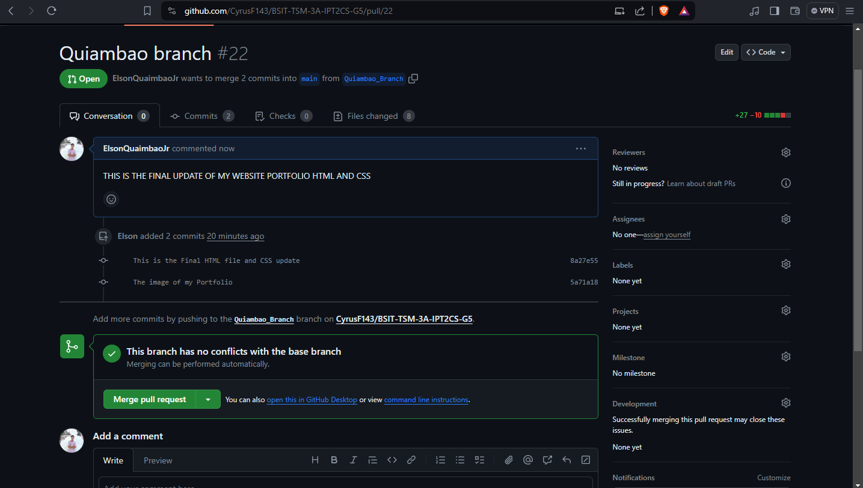

**IN THIS PICTURE, IS MY FINAL PULL REQUEST OF MY HTML FILE AND CSS DESIGN IN THE GITHUB REPOSITORY**

**IN THIS PICTURE, I AM STARTING CREATED MY DOCUMENTATION AND TOTALLY FINISH, ABOUT CREATING MY PORTFOLIO**

**IN THIS PICTURE IS THE FINAL PUILL AND MERGE IN MY BRANCH AND TOTALLY SUCCESSFUL MERGE.**

### **Local Repository (Git)**

**CLONING REPOSITORY FROM GIT TO GITHUB USING GITBASH TERMINAL.**

This is cloning copy the url and then cloning repository from github to gisbash terminal.[1]

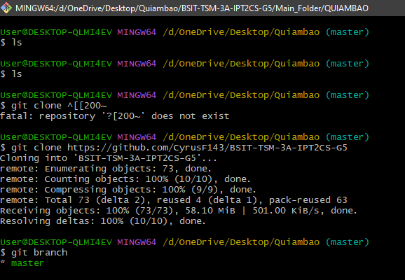

**This terminal you see the bash terminal and then I type git clone and insert the url of the repository to clone the repository. The git clone command copies an existing Git repository.[2]**

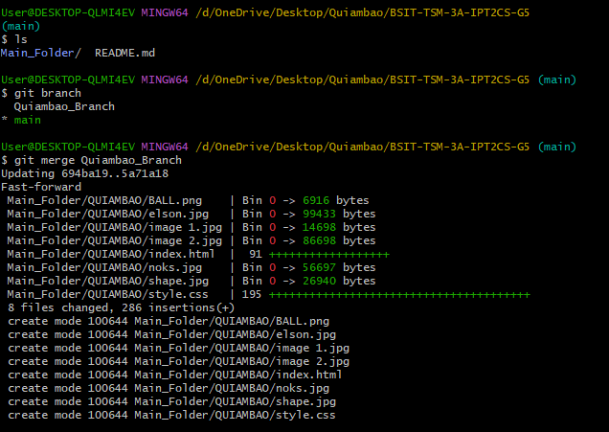

**This picture is I merge my local branch to my main repository.** **The git merge command lets you take the independent lines of development created by git branch and integrate them into a single branch. Note that all of the commands presented below merge into the current branch.[3]**

**Working on local-repo and creating a local-branch.**

**In this part I created my branch in clone local repository and name it to my last name Quiambao-Branch.** **Git branches are effectively a pointer to a snapshot of your changes. When you want to add a new feature or fix a bug—no matter how big or how small—you spawn a new branch to encapsulate your changes.[4]**

**In this picture I add my branch in main folder to my perspective folder, and this branch is untracked by using git add the branch is now tracked. The git add command adds a change in the working directory to the staging area.**

**In this part is I commit the branch for working free clean now the branch is in staged.** **The git commit command is one of the core primary functions of Git. Prior use of the git add command is required to select the changes that will be staged for the next commit. Then git commit is used to create a snapshot of the staged changes along a timeline of a Git projects history.[5]**

**In this part I push my branch in to the local repository and successfully pushed/ the git push command is used to upload local repository content to a remote repository. Pushing is how you transfer commits from your local repository to a remote repo.[6]**

**This picture is to fetch my branch in our main repository to downloads all commits** **n review, git fetch is a primary command used to download contents from a remote repository. git fetch is used in conjunction with git remote , git branch , git checkout , and git reset to update a local repository to the state of a remote. The git fetch command is a critical piece of collaborative git work flows.[7]**

**CREATING MY FIRST VERSION OF MY HTML**

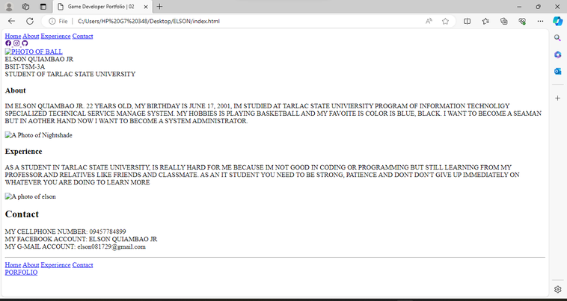

**THIS IS MY HTML PORTFOLIO NO DESIGN IN CSS AND THE BASIC INFORMATION ABOUT ME AND EXPERINCE AND CONTACT.**

**THIS PICTURE IS MY HTML FILE IS TO ADD COMMIIT PUSH ON THE REPOSITORY TO MAIN AND PERSPECTIVE FOLDER.**

**AND THIS PART IS THE OUTPUT OF MY FIRST PULL REQUEST IN MY REPOSITORY**

**ADDING CSS DESING**

**IN THIS PART I DESIGNING MY HTML FILE PORTFOLIO USING CSS AND THIS IS THE OUTPUT OF MY HOME PAGE. ABOUT, EXPERIENCE AND CONTACT.**

**AND THIS PART IS THE GITBASH TERMINAL TO ADD COMMIT AND PUSH CSS DESIGNE TO UPDATE MY HTML FILE PORTFOLIO WEBSITE**

**THIS IS THE SECOND ADD COMMIT AND PUSH OF MY HTML FILE PORTFOLIO TO UPDATE**

**AND THEN THIS IS THE SECOND PULL REQUEST OF MY HTML FILE**

**THIS IS THE FINAL UPDATE OF MY HTML FILE AND CSS AND THE LAST PULL REQUEST AND MERGE.**